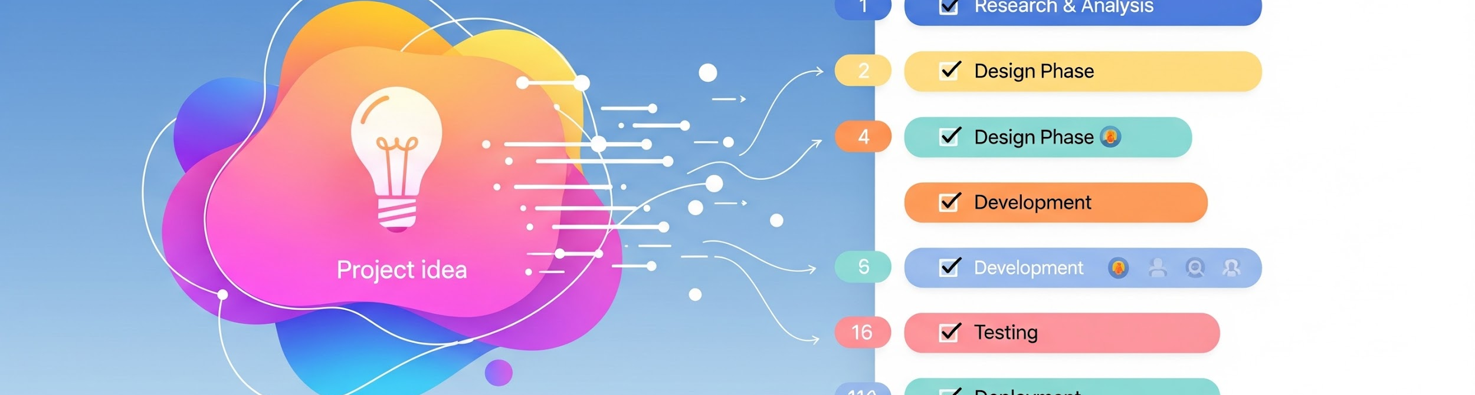

Project Builder & Task Tracker Feature Specification

1. Feature Overview
Feature Name | Project Builder & Task Tracker
Feature Purpose | This feature helps students convert a project idea into structured, step-by-step tasks based on the selected technology stack. It ensures learners understand what to do, in what order, and track completion visually.
Target Users | Students, Learners working on technical projects

2. Minimum Viable Product (MVP) Scope
Must-Have | Out of Scope (Not Now)
Project route (/project) | Code generation
Tech stack dropdown | File uploads
Project name input | GitHub integration
Static project suggestions (3 total) | Collaboration
AI-generated task breakdown
Checkbox-based task completion
Data persistence

3. Frontend Flow & UI Requirements

3.1 Feature Entry Point
The user will access the feature from the Dashboard.

- User clicks on "Projects"
- User is redirected to the new route: /project

3.2 Project Page UI Elements
The Project Page must contain the following interactive elements:

UI Element | Details
Tech Stack Dropdown | A dropdown menu with the following static options: MERN Stack, MEAN Stack, MEVN Stack. Only one stack can be selected.
Project Name Input | A text input field where the user enters the Project Name. Example: "Student Management System".

3.3 Static Project Suggestions
After the user enters the project name, the system will display exactly 3 static (frontend-only, no AI) project suggestions.

Purpose: To give clarity and avoid overwhelming the user with dynamic options.

3.4 Task Display & Interaction
Tasks generated by the AI will be displayed in a list format.

- Each task item must contain:
  - Task name
  - Checkbox on the left

Task Completion
When a user completes a task, they tick the checkbox. This action marks the task as completed and the status is saved in the database.

4. Backend Functional Flow

4.1 API Trigger
The frontend sends a request to the backend API when the user:

- Selects a tech stack
- Enters a project name

Example Request Body:{

"techStack": "MERN",

"projectName": "Student Management System"

}

4.2 AI Processing & Constraints
The backend is responsible for the following sequence:

Step | Action
1 | Receive techStack + projectName
2 | Construct a prompt using the selected tech stack and project name
3 | Call AI API
4 | Constraint: Request STRICT JSON response
5 | Constraint: AI is used only to break the project into tasks

AI Expected Output (Strict JSON format):{

"projectModules": [

{ "task": "Set up project folder structure", "completed": false },

{ "task": "Create backend server", "completed": false },

{ "task": "Design database schema", "completed": false },

{ "task": "Build frontend UI", "completed": false }

]

}

5. Data Storage (Database)
The system must store the following structure for each project to allow progress tracking and persistence across sessions:

Field | Data Type/Purpose
userId | User Identifier (Person)
projectName | Name of the project
techStack | Selected technology stack
tasks | Array of task objects
tasks[].taskName | Name of the sub-task
tasks[].completed | Boolean (true/false)

Example Schema:{

"userId": "...",

"projectName": "...",

"techStack": "...",

"tasks": [

{ "taskName": "...", "completed": true }

]

}

6. Success Criteria
The feature is considered successful if all of the following conditions are met:

- User can successfully create a project.
- Tasks are generated in an ordered, step-by-step manner.
- User can check tasks as completed using the checkbox mechanism.
- Progress (completed status) is saved and restored correctly across sessions.

